UC-22: Prescribe Medications
Doctor prescribes medications and generates prescription.

Activity Diagram:
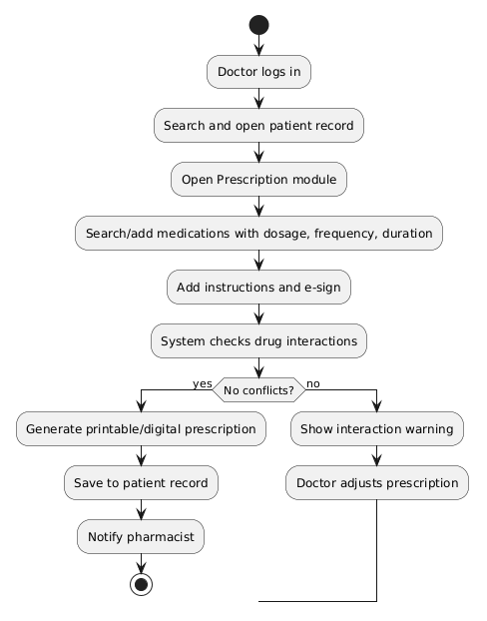

Sequence Diagram
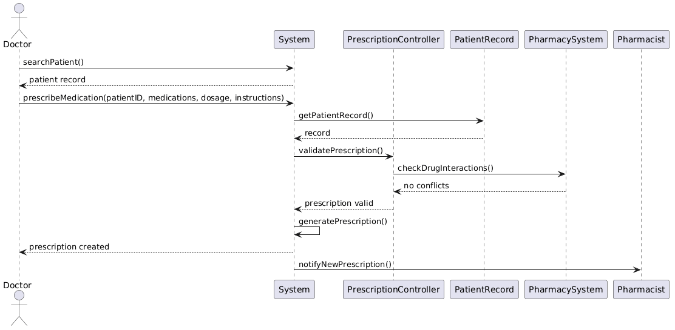

Collaboration Diagram:
